Kyle Klausen

CSD-325

Assignment5.2

06/14/25

**Flow chart to represent the code:**

I've been using a new flowchart tool which has helped me clean up the lines and shapes for my flowcharts, but even with that help this week was very challenging for me. I am unsure if I was successful at understanding the code and creating the flowchart which reflects that, but I did try my best to interpret it efficiently.

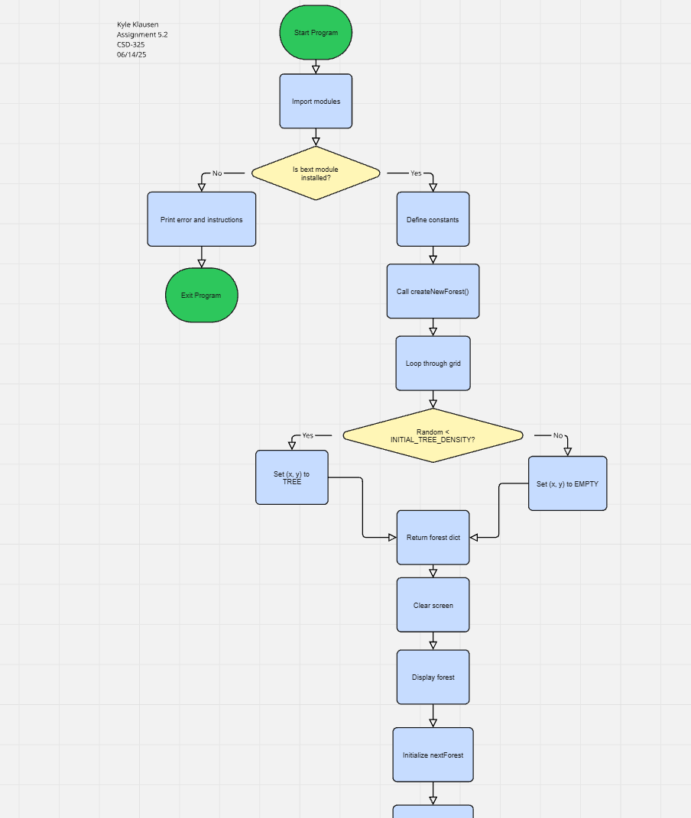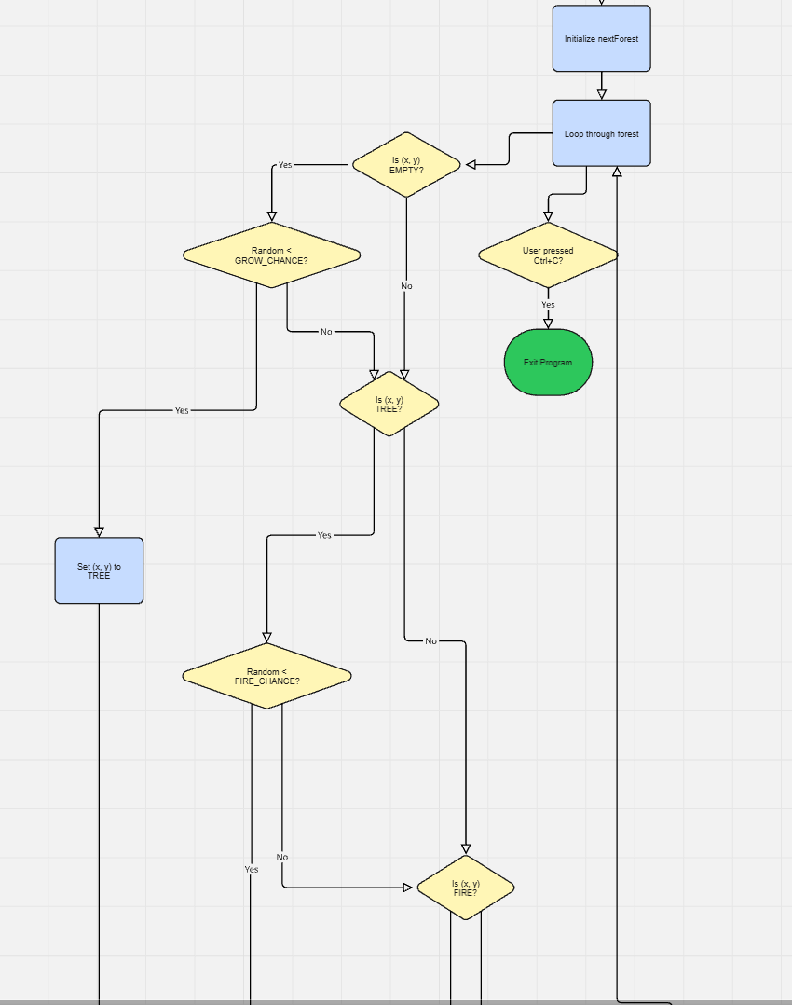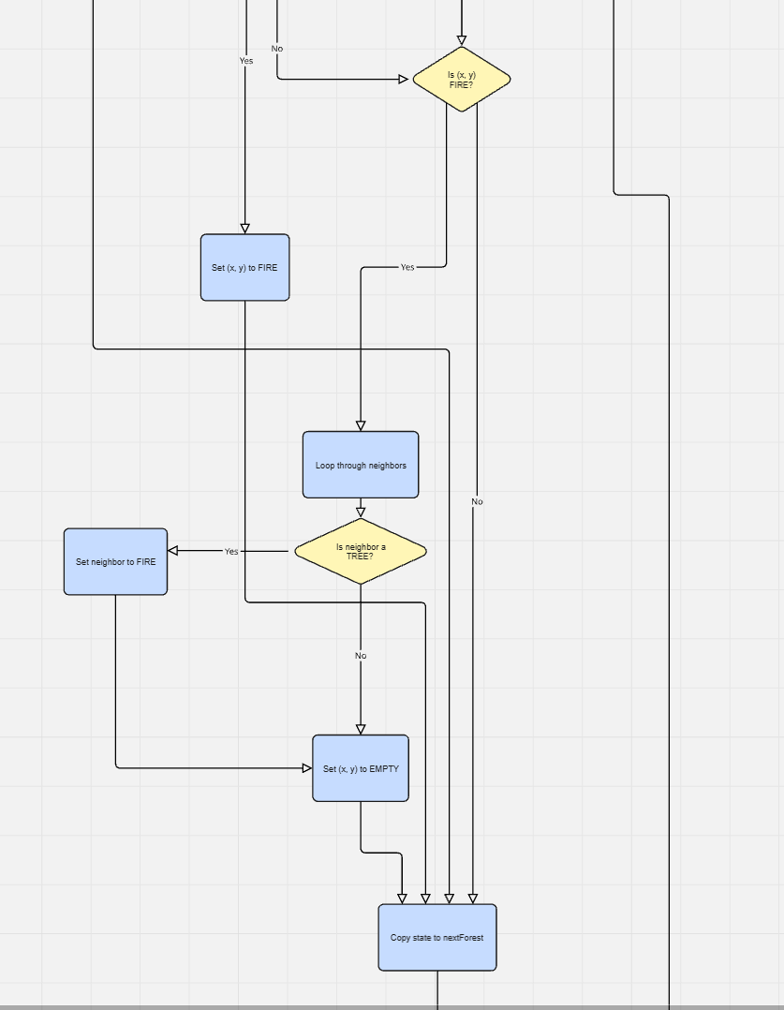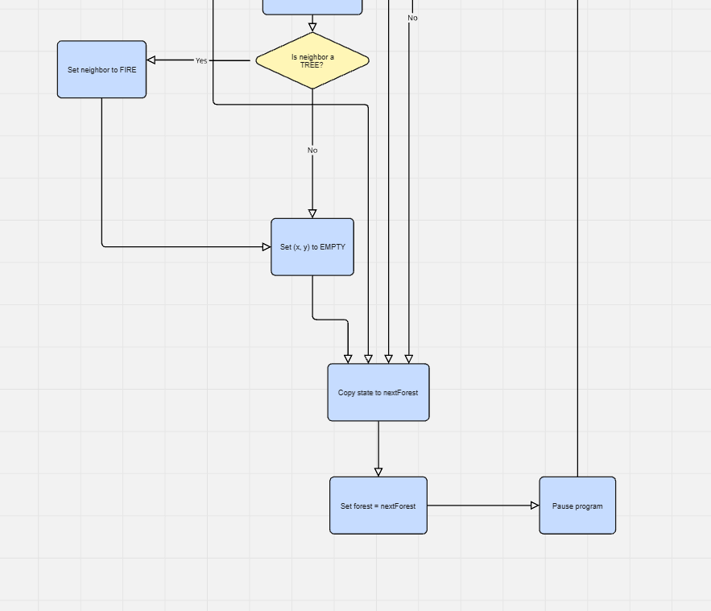

Screenshots of the amazing code running:

